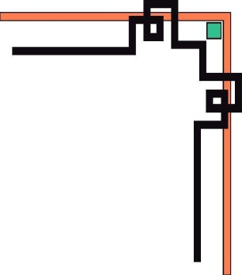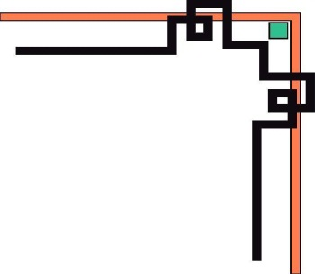

**HO CHI MINH CITY OPEN UNIVERSITY**

FACULTY OF INFORMATION TECHNOLOGY



**MOBILE PROGRAMMING REPORT DOCUMENTS**

***Topic: Building an exercise app***

***Student group:*** Nguyen Thi Phuong Thao

Phan Minh Tuan

Phong Chan Xung

Nguyen Duc Thinh

Ngo Tran Duy Thien

**Ho Chi Minh City, May 15, 2021**

**TABLE OF CONTENTS**

Page

**A.SPECIFICATIONDOCUMENTSREQUIRESOFTWARE............................... 4**

I. INTRODUCTION 4

1. Objective 4
2. Range 4
3. Terms and acronyms 4
4. References 4
5. Document Description 4

**II. SOFTWARE OVERVIEW** **5**

1. General software requirements 5
2. Functionality of the software 5
3. User Object 5
4. Constraints 5
5. Assumptions and dependaes 5

III. SOFTWARE REQUIREMENTS SPECIFICATION 6

1. External interfaces 6

B. INSTRUCTIONS FOR USE 10

1. **SOFTWARE REQUIREMENTS SPECIFICATION DOCUMENTS**
2. **INTRODUCE**
3. **Goal**

The purpose of this document is to provide a detailed description of the requirements for the software that supports the exercise. This document will fully state the constraints of the system, the user interface.

1. **Scope**

Fitness software is installed on smartphone devices, making it easy for people to work out at home when they don't have much time to go to the gym. In addition, the application also helps the trainees regain their physique when practicing according to the process.

1. **References**

[1] Android Programming - The Big Nerd Ranch GuideFile.

[2] Professional Android 4 Application DevelopmentFile.

[3] Silde lectures on Mobile Programming provided by the instructor.

**5. Document Description**

|  |  |  |
| --- | --- | --- |
| Part | Depict | Purpose |
| 1.Introduction | Description in the most general way, scope, purpose of the document to be achieved | Give the work to be done of the document |
| 2.Software overview | Software overview | General software, objects of use |
| 3.Business process analysis | Functions of the system | Analyze the business process in the most specific way. |
| 4.Request specification | Software performance and functionality requirements | Present the requirements that the software needs to enforce |

1. **SOFTWARE OVERVIEW**
2. **General software requirements.**

The software system includes: Exercises, workout days and information management in the SQLite database(Height, weight, BMI, gender, workout schedule).

1. Exercises, workout days:

* The user clicks on the workout shapes, selecting the workout by day.
* The system starts the exercise, which is timed.

1. Manage information in a SQLite database.

* Store height, weight, BMI, gender, workout schedule that tracks the development of the trainer🡪

1. **Functionality of the software**
2. Provide exercises at home.

* The trainees can select the exercises on the interface of the application.
* When the trainer wants to monitor the parameters of the body such as height, weight, BMI system conducted for the person practicing data entry, weekly tracking and save to the database.🡪
* Set daily workout times.

1. Provides a customized workout process.

* The trainees can coordinate the exercises together as desired.
* The workout video is clear.

1. **User object.**

* The software is applied to the user audience: Customer.
* The trainer uses the app directly, and can create a workout plan for himself.
* Monitor your workouts.
* Set your own workout time.

1. **Constraints.**

* The system requires users to enter the new height and weight to calculate the BMI to help users monitor the development of the body.🡪

1. **Assumptions and dependaes**

The software is only smart mobile devices, then the software system can connect to the SQLite database built into the application.

1. **SOFTWARE REQUEST SPECIFICATION**

This section includes all the functional requirements and quality of the system. It gives a detailed description of the system and all its functions.

1. **External interface requirements**

* This section provides a detailed description of all input and output elements from the system. It also describes the hardware, software interface, and provides a basic sample of the user interface.

1. User interface:

* 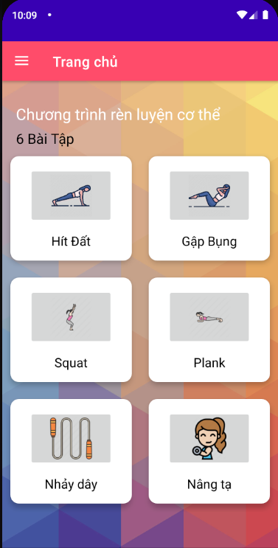When the user opens the software system, it will display the interface as shown in Figure 1, from which the user can select exercises.

Figure 1. Main interface of the application

* 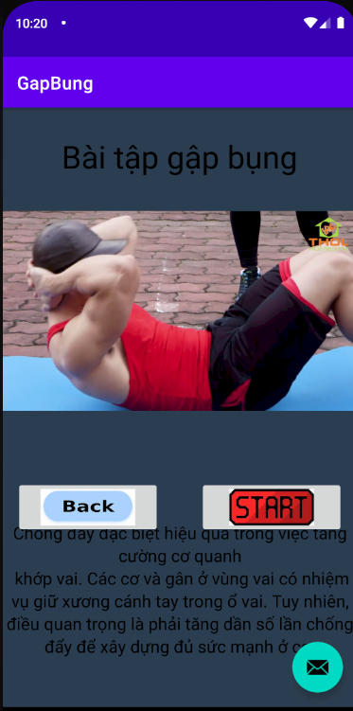After selecting the appropriate workout, will display the workout interface, Figure 2. Along with video tutorials and information about the workout performance of the workout.

Figure 2. Workout interface.

* The user who clicks Start displays the look and feel as shown in Figure 3.
* The user selects the workout date and conducts the workout by default or custom time.
* 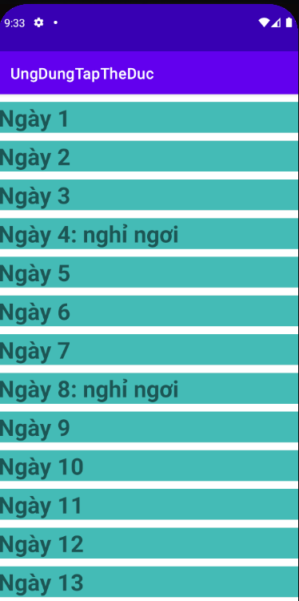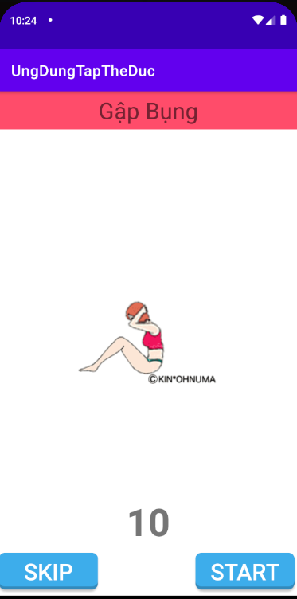Users can enter body parameters for the app to track and calculate BMI only.

Figure 3. Workout date interface and exercises

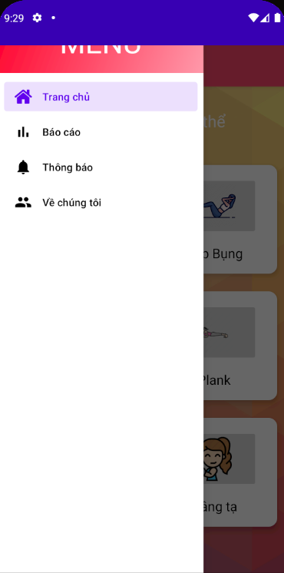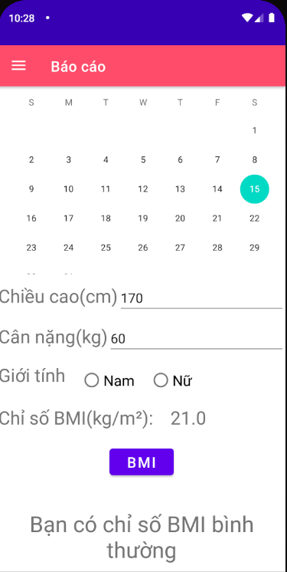

Figure 4. Body index tracking interface

1. Hardware interface

* Smart mobile phones and SQLite databases.

1. Software interface

* The workout interface gives users the freedom to choose the form and method of training.
* Reporting interface: allows users to track time, height, weight, BMI.

1. **INSTRUCTIONS FOR USE**
2. After downloading the application, start up, the home page interface appears as shown in Figure 1.
   * Users can choose from workouts

Figure 1.

1. When clicking on the interface of the workouts will appear the interface as shown in Figure 2 and Figure 3.

* There are detailed video tutorials and specific descriptions of workouts that will help users easily work out at home.

Figure 2. Figure 3.



Figure 4.

1. The gadget tracks workout days and body indicators as pictured 5 and Figure 6.

* When a user clicks on a report item, it displays a 6-shape interface for easy input of metrics and tracking.

Figure 5. Figure 6.